Policy Framework and Procedure
This framework applies to policy owners and Housing 21 employees responsible for writing policies to be published across Housing 21.

Policies are an essential part of an organisation, providing a roadmap to how the business operates, ensuring compliance with laws and regulations, and providing guidance for decision making along with streamlining internal processes.

The policies and procedures that are produced by Housing 21 need to provide our employees with a set of standards and/or rules to be followed, providing clear guidance on the roles and responsibilities of individuals, or groups of individuals, and ensure that day to day requirements are transparent. Following policies and procedures ensure that as an organisation Housing 21 meet legal, regulatory, and good practice requirements which protects our employees and our residents from harm or wrongdoing, while reducing any reputational or financial risk to the organisation.

To ensure all policies and procedures that are produced and reviewed by Housing 21 follow a consistent process, the following framework is in place focussing on the development, approval, and management of policies and procedures. All policies and procedures adopted within Housing 21 will be documented in line with the Policy Framework requirements.

The policy framework provides the following:
- Key steps to be followed when producing, illustrated by a flowchart for both new policies and the review of existing policies.
- A clear policy format to follow to ensure consistency across Housing 21 (Appendix 1).
- Guidance for how to write policies (Appendix 2)
- A policy checklist to be completed for all policies referencing the considerations that have been made when producing a policy (Appendix 3).
- The approval process and further documents to be completed including the Data Privacy Impact Assessment (DPIA – Appendix 4) and an Equality Impact Assessment (EIA – Appendix 5).
- Roles and responsibilities of key stakeholders in the oversight and production of policies at Housing 21.
- A policy tracker is in place to provide oversight of all Housing 21 policies and their intended review dates.
Key steps outlined in the framework:
￼

Contents
1. New policy process flowchart 3
2. Policy / Procedure development 4
3. Equality Impact Assessment (EIA) 5
4. Policy approval process 5
5. Policy format 6
6. Policy checklist 6
7. Policy Data Privacy Impact Assessment (P-DPIA) 6
8. Communication of policies 7
9. Policy is no longer required 7
10. Reviewing an existing policy 7
11. Policy review 9
12. Policy tracker 9
13. Reporting on the policy framework 9
14. Roles and responsibilities 9
14.1 The Board / Committees 10
14.2 Executive Directors and Leadership Team 10
14.3 Policy Steering Group 10
14.4 Subject Matter Experts / Policy Owner 10
14.5 Individual Employees / Groups of Employees 11
14.6 Residents 11
14.7 Learning and Operational Development (L&OD) 11
14.9 Communications Team 12
14.8 Appendices to the framework 12

1. New policy process flowchart
The following flowchart details the key steps to follow when a new policy is needed with further guidance provided within the framework document.
The policy owner (subject matter expert) should consider whether any of the following apply
• Is there a legal and or regulatory compliance requirement that needs to be maintained
• Is there a requirement for consistent standards to be applied across a function or the organisation to meet good practice and or
organisational aim and or objectives
• No other related policy is in place that can be amended to include new policy requirements
Note-if Director or
Policy Steering Group reject a draft policy
revisit policy requirements and
assessments
N
Y
Policy need identified
Develop Policy
Develop guidance documents or general
Involve external expert/legal
Complete EIA
Involve employees residents
Complete Checklist
Complete P-DPIA
Initial Director review
Reviewed by Policy Steering Group
Y
Final Executive /
Board approval
Y
Y
Publish on Intranet
Implement Communications
Complete Update tracker /Monitor

2. Policy / Procedure development
The key steps detailed within the flowchart should be followed when developing new policies. A policy is required to be documented when:
- A legal and or regulatory compliance requirement needs to be maintained
- There is a requirement for consistent standards to be applied across a function or the organisation which involve complex decision making and a requirement to meet good practice and organisational aims or objectives.
Before developing a new policy, all other related policies should be reviewed to determine whether a new policy is needed or whether additions to an existing policy would be better
Heads of Service should review the polices for their area and identify and address any gaps. Consideration should be given where standalone procedures may be required in place of a formal policy. This should be discussed with the policy owners and Heads of Service.
For clarity, a Policy is a statement of intent, describing the approach or course of action the organisation is taking in respect of a particular issue. A Procedure is the detailed steps taken to fulfil a policy.
For Housing 21 policies and procedures should be carefully documented to ensure that they are compliant with any legal and regulatory obligation, but also on balance do not place onerous obligations that the organisation may not or cannot comply with. Documented policies and procedures should be clear, concise and user friendly and detail set standards which need to be complied with, there being no ambiguity in what is expected from individuals, groups or a task or process. They should adhere to our brand guidelines to ensure accessibility and where published or shared with residents, meet our branding requirements.
Within some policy areas, we use terms relating to the governance or nature of the business. The following considerations should be applied:
- Housing 21 is a community benefit society regulated by the FCA and subject to the Co-operative and Community Benefit Society Act. A “organisation” on the other hand is subject to different rules found within the Companies Acts. When referring to Housing 21 it is best to use terms like “Association” and “Society” instead of organisation to avoid potential confusion;
- Housing 21 has a Board but none of the Executive Team are Managing Directors. Whilst the Board has ultimate responsibility for the governance of the Association, when allocating responsibility a policy author should be careful to clearly identify who is being referenced. Only use “director” when referring to members of the Board. Otherwise use “Executive Team member” or identify the specific role e.g. “Chief Finance Officer”;
- The law frequently imparts specific meaning to specific words and using the wrong word can unintentionally change the meaning or scope of a policy. By way of example an “employee” means someone who has a contract of employment. A “worker” would include self-employed freelance or agency workers. If you intend your policy to apply to this broader group either use the term worker or make it clear somewhere else within the policy that when you reference employee or colleague this also includes people who don’t have an employment contract

3. Equality Impact Assessment (EIA)
An EIA is required to be completed for all policies (Appendix 4) and includes where to seek further advice and the sign off requirements.
The aim of the EIA is to ensure that a policy does not unintentionally discriminate against any protected group. Completion of an EIA assists in identifying whether anyone will be treated less favourably than anyone else because of their sex, age, disability, race, religion or belief, sexual orientation, marital status or socio-economic status.
It is important that an EIA is completed early in the process of writing or reviewing a policy to try and understand what the impacts might be, so the final version includes any changes as a result of this assessment to mitigate any negative impacts that the policy might have had otherwise.
In conjunction with Board, we have agreed an Equality, Diversity and Inclusion statement to be included in all policies:
“Housing 21 aspires to embed diversity and inclusion within all our organisational activities to enable these principles to become part of our everyday processes."

4. Policy approval process
Heads of Service and the relevant Executive Director should provide initial approval of the policy and depending on the nature of the policy, further approval may be required from the Board as per the Board Policy Framework. The Board and / or its committees reviews and approves policies which are of strategic / legal / regulatory importance / significance.
Prior to final / Board approval, the policy and policy checklist will be reviewed by the Policy Steering Group, and if required, then to the relevant Executive Committee ahead of progressing to Board
It is important that relevant polices are also reviewed by an external subject matter expert / legal counsel where the area has a significant or complex legal and or regulatory aspect. This review must be completed prior to the first approval stage by the Heads of Service and the relevant Director.
The full suite of the Policy Framework requires submitting to the Strategic Operations Team ahead of the Policy Steering Group via their email address PolicySteeringGroup@Housing21.org.uk to include: the framework checklist, the policy, the EIA and the P-DPIA.
The team will issue these, and query logs to the Policy Steering Group ahead of the review date for them to log any queries they have against the policy or framework checklist. The query logs are made available to the policy author to respond to ahead of the Policy Steering Group meeting, to which the policy authors are invited to discuss the review.
Following approval either by the Policy Steering Group, Executive Committee or Board, the policy author can the implement publishing and communication of the policy as per section eight of this guidance.

5. Policy format
Each policy is required to be documented using a standard format (Appendix 1 – policy sample template) and the brand guidelines which are available on Wilma. In addition to the standard formatting of policies, policy writers and owners should consider including:
- Why the policy is needed including references to relevant law, regulation, strategic aim?
- The key principles of the policy
- The implication of not following the policy
- How the policy will be implemented in terms of training and awareness opportunities
- How compliance with the policy will be reported, to whom and the frequency of reporting
- References to links to additional management guidance / supporting forms where required

6. Policy checklist
Prior to a policy being reviewed and approved, a Policy Checklist will need to be completed and submitted to the Policy Steering Group to support the new or reviewed policy, as in line with the process. See Appendix 3 – Policy Checklist.
The checklist is in place to ensure the policy author / subject matter expert has considered all relevant matters. In addition to some areas which are required by the policy format, areas which need to be documented in the checklist include additional narrative around:
- How the policy meets the organisations strategic objectives
- Whether external or legal assurance is required
- Whether the policy requires board approval
- Whether the policy has been reviewed and tested by those the policy is intended for (our people or residents)
- Significant risks associated with the policy and risk mitigation
- Significant value for money considerations.
The checklist will be reviewed by the Policy Steering Group to ensure all aspects have been appropriately documented and considered before a new policy can be approved.

7. Policy Data Privacy Impact Assessment (P-DPIA)
A P-DPIA is required to be completed where a policy involves the processing of personal and or sensitive data e.g. residents’ data, applicants’ information or employee’s data.
The aim of the P-DPIA is to identify controls over the processing of data which ensure the integrity and safety of that data within our systems.
See Appendix 5 P-DPIA Screening questions and where to seek further advice and the sign off requirements.

8. Communication of policies
The intranet site (Wilma) will be the primary location for all policies and procedures with relevant policies and procedures also be published on the Internet site. We have designated employees for uploading policies to the intranet to ensure version control. Please email new policies to be uploaded to PolicySteeringGroup@Housing21.org.uk and please also notify of old policies to be removed and any associated documents with their hyperlinks.
The relevant subject matter expert / policy owner should take responsibility for distributing the policy or procedure to the relevant groups who will be responsible for implementing if the policy does not apply to all employees.
All policies and procedures should include a clear communication and implementation plan which sets out:
- Recipients for information / Recipients for action
- Mandatory training required
- Any formal process such as signing for receipt to meet legislative requirements

9. Policy is no longer required
When a policy is no longer relevant, or it has been incorporated within a different policy the policy author should seek from approval from the relevant Head of service to delete the policy. The author should inform the Policy Steering Group to update the policy tracker and ensure the documents are removed from Wilma. This can be done by emailing PolicySteeringGroup@Housing21.org.uk

10. Reviewing an existing policy
The following flowchart outlines the steps to follow when a policy is already in place, but a formal review is needed.

11. Policy review
All policies, strategies or procedures should be reviewed in detail every three years as a minimum, or sooner if there is a specific legislative or service requirement or change in guidance, law or practice. Reviews should take account of:
- changes to organisational and national policy and context
- changes to law, regulation and or good practice
- the ongoing requirement for the policy or procedure
The relevant subject matter expert / policy owner should take responsibility for ensuring that review takes place at the appropriate time with review timescales included in the policy document and policy tracker
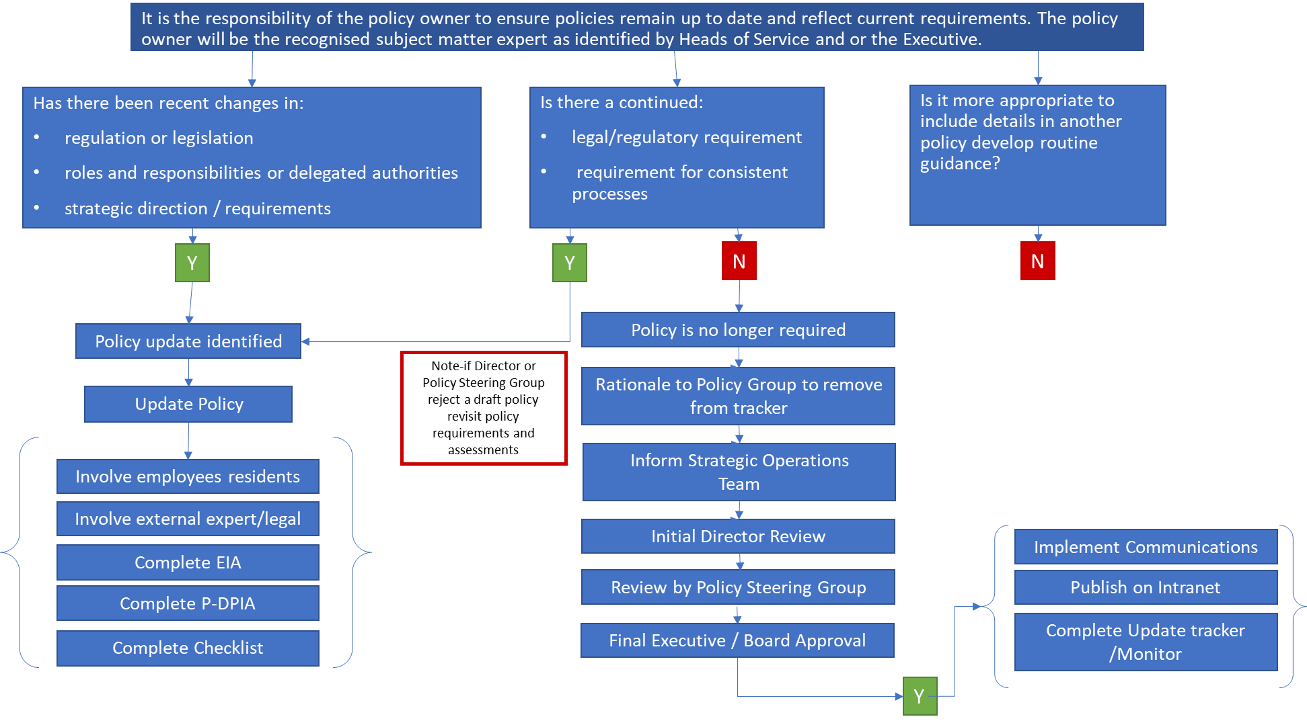

12. Policy tracker
A policy tracker will be maintained to ensure a comprehensive list of policies and procedures are maintained. The tracker will be visible for all Housing 21 employees on the Intranet in the policy section.
The tracker will detail requirements for policies on:
- Board / Committee / Executive approval
- Legal review
- General review timescales

13. Reporting on the policy framework
The Policy Steering Group will review compliance with the Framework on an ongoing basis as per the Groups Terms of Reference.
The Chair of the Policy Steering Group will report to the Executive and Audit and Assurance Committee on a six monthly basis providing assurance over:
- Effectiveness of the overall framework and work of the Policy Steering Group
- Timeliness of policy reviews and updates
- Compliance with external subject matter expert / legal review
- Compliance with Board approval requirements
- Effectiveness of the Equality Impact Assessments in highlighting and addressing equality concerns.

14. Roles and responsibilities
Whilst policies and procedures apply to every employee at Housing 21, the below outlines the main responsibilities attached to each of the following groups:

14.1 The Board / Committees
- Provide strategic leadership and direction, setting the tone in respect of legal, regulatory and policy compliance.
- Reviews and approves policies which are considered to be of strategic / legal / regulatory importance / significance as per the Board Policy Framework.
- Pro-actively challenge the Executive and Senior Management on policy matters and seek assurance on compliance where appropriate.

14.2 Managing Directors and Leadership Team
- Review and approve policies which are within their delegated authority as per the Board Policy Framework.
- Executive to report policy compliance to the Board, which are considered to be of strategic / legal / regulatory importance / significance and in line with agreed Board Policy Framework.
- Build a compliance culture across the organisation and ensure compliance with policies across individual teams and departments.
- Regularly review policies and procedures to ensure they are appropriate and ensure compliance with regulation and legislation.

14.3 Policy Steering Group
Operate in accordance with the groups Terms of Reference, in particular ensuring good governance and oversight ensuring all Housing 21 policies:
- Enable Housing 21 to meet its strategic objectives in a collaborative and joined-up manner ensuring there are no gaps in the policy framework
- Make clear who the intended audience is and are easily accessible
- Have been reviewed and tested by those the policy impacts on – including residents and employees
- Have been tested against relevant laws and regulation including external or legal assurance where there is a significant or complex legal and or regulatory aspect
- Have been subject to appropriate levels of independent scrutiny and review
- Have been reviewed or updated in line with agreed timescales
- In a temporary measure, until all the policies have passed through the policy framework, the group will offer feedback on the contents of the policy being reviewed in addition to meeting the requirements of the framework itself. Commentary will be based on the members areas of expertise and as part of the audience for which the policy is intended.

14.4 Subject Matter Experts / Policy Owner
- Develop and document policies and procedures relating to their area of expertise, obtaining feedback from employees and or residents as appropriate.
- Undertakes horizon scanning in order to identify required changes in policy as a result of changes in legislation, regulation and or good practice.
- In documenting policies ensure that all policy requirements are met including the documentation of a further Equality Impact Assessment and where relevant a Data Impact Assessment
- Where applicable, in line with the framework periodically seek third party assurance that policies and procedures are fit for purpose and are compliant with any legal and regulatory obligation.
- Ensure related communications are fit for purpose with the Intranet being the main repository for documents, providing regular updates / insights to raise awareness of policy requirements.
- Ensure related mandatory training plans have been documented, with regular monitoring of compliance with completion, escalating areas of concern.

14.5 Individual Employees / Groups of Employees
- Understand and implement policies and procedures relevant to their role.
- Complete mandatory training in respect of policy and procedure compliance.
- Report inefficient, unnecessary or unworkable controls which relate to policies and procedures.
- Raise concerns where policy and or procedure requirements are not being followed, and support and cooperate with management on related investigations. Concerns can be raised using the whistle blowing policy.
- Support the development of policy and procedures either as a subject matter expert or as part of routine focus and interest groups periodically commenting upon and influencing proposed policies and procedures

14.6 Residents
- Support the development of policy and procedures as part of routine focus and interest groups periodically commenting upon and influencing proposed policies and procedures
- Through focus and interest groups routinely comments upon strategic and operational performance relating to specific policy with a view to improve service quality and the resident experience.

14.7 Learning and Operational Development (L&OD)
- L&OD will work with the policy author to develop an implementation plan and ensure the appropriate training is in place. This should include ensuring any existing training that includes a reviewed policy is highlighted and brought up to date.

14.9 Communications Team
- The Strategic Operations Team will publish all policies on the intranet received from the policy owner or author and work with the policy author to support development of an implementation action plan.

14.8 Appendices to the framework
  - Appendix 1 – Policy Template
  - Appendix 2 – Sample Framework Checklist and Good Practice Example
  - Appendix 3 – Policy Checklist for Sign Off by the Policy Group
  - Appendix 4 – Equality Impact Assessment
  - Appendix 5 – DPIA Screening Questions
  - Appendix 6 - Resident Engagement Template

