Meeting notes
Service Charge Network

Date: 13th March 2026
Time: 2pm
Housing 21 Lead: Tracy Jones - Head of Operational Development
Resident Lead: Tom Long

Housing 21 Representatives:
Richard Wheeldon - Head of Retirement Living – West
Lucy Nixon – Resident Communications Manager
Amber Crick – Resident Engagement Coordinator

Housing 21 residents: AA, ID, MR, SM, DD, DB and TA

Apologies: RB

Date of next meeting: Thursday 23 April 2026 (new day)
Time of next meeting: 2pm
Title of agenda item |  | Summary of discussion
1. | Welcome and Introductions | Tracy opened the meeting and confirmed all attendees had received the previous minutes and current agenda.
2. | Review of Previous Meeting Minutes | Tracy reviewed progress against all previously agreed actions.  Updates Provided:  - Complaints Workflow: Reviewed with Maddie; adapted to a full-year service charge workflow. Draft shared with TL, ID, and MR.  - PFI Vlog: Still being worked on; dependent on accountant responses.  - Utilities Query: Communal utilities through service charge are part of Section 20; individual meters are not.  - Appello Training/Podcast: Not yet developed; Richard Wheeldon will see if there are existing videos from Appello.  - Survey of Managers: Sent to area managers; limited response received. Full update later in meeting.  - Rent Letter Feedback: Positive overall, but several errors reported at one scheme – causing resident distress. Tracy will investigate with Richard Lawton.
3. | Future Vlogs – strategy and plan | Future Vlogs – Strategy & Plan  Lucy joined the meeting for this section.  The group discussed script updates and the next filming date.  Agreed:  - Merge scripts for court manager services, repairs, utilities, and service charge overview.  - Avoid filming core-support charge content until Sophia's paper is complete.  - Explore including Appello content once Richard Wheeldon reviews resources.  - Recording date is set for Thursday 19 March at 3:30pm.  Related Discussion Falling Under This Block:  Residents expressed:  - Vlogs improve understanding when used — but few managers actually show them.  - Some courts have never shown a vlog, despite organisational encouragement.  - Vlogs need to be simple, consistent, and widely used.
4. | Service Charge manager survey  (Results included after minutes) | Amber presented findings from the 17 responses.  What Worked Well:  - Guidance, FAQs, and crib sheets.  - Richard Lawton’s preparatory sessions.  - Templates that helped managers structure meetings.  What Didn’t Work Well:  - Only one manager showed the vlogs at every meeting.  - Last-minute changes caused confusion.  - Low response rate.  Related Discussion Falling Under This Block:  Residents raised that:  - Missed opportunities to use vlogs to help understanding.  - Managers need clearer expectations to demonstrate consistency.
5. | Service Charge forum priorities | This section was picked up in parts throughout the meeting. The group identified recurring issues that should form 2026/27 priorities:  Key Priorities Identified:  - Improve clarity and consistency of service charge documents.  - Create clear version control: draft/final, date, version number.  - Strengthen managers’ confidence and capability during meetings.  - Standardise information given to residents across all schemes.  - Improve feedback collection from residents after each meeting.  - Increase use of vlogs during meetings to support understanding.  Related Discussion Falling Under This Block:  A major discussion on the devolved model occurred here:  - Some managers feel empowered; others overwhelmed.  - Performance varies hugely between courts.  - Residents raised strong concerns about inconsistency.  - Tracy confirmed this feedback will be sent to Sophia.
6. | Service Charge workflow  (presentation slide included) | Tracy presented the full-year workflow showing when budgets, letters, statements and meetings happen.  - Jan: Service charge budgets set  - Feb: Rent & service charge letters sent  - Aug–Sept: End of year statements  - Sept–Nov: Contractor quotes gathered  - Nov–Dec: Service charge review meetings  - Feb–Apr: Vlog production to support resident understanding  Resident Feedback:  - Documents must clearly show status (draft/final), date and version.  - Residents across schemes want more transparency about when each stage happens.  - Annual review should compare results to previous years.  Related Discussion Falling Under This Block:  - The group agreed that the workflow will help enforce consistency.  - Tracy confirmed it will be published on the Housing 21 resident website.  - Discussion on needing clearer guidance for managers across regions.
7. | AOB | Several topics emerged throughout and were captured in this block.  Topics Discussed:  - Appello training & accessibility: Need clearer instructions and wheelchair-friendly screen heights.  - Digital feedback: Interest in using QR codes, tablets or Appello pop-ups for quick surveys after budget meetings on court.  - Hearing loops: Many courts have loops installed but no training on how to use them.  - Utility & water billing issues: Some schemes have ongoing water billing problems; others have unexpectedly large utility increases.  - Meeting schedule change: Move from Fridays to Thursdays; meet every 6 weeks.
8. | Follow-up tasks: | - Tracy to continue refining complaints/service charge workflow.  - Tracy to follow up with accountants on PFI vlog.  - Tracy to investigate rent letter errors with relevant regions.  - Tracy to raise devolved-model concerns with Sophia.  - Tracy to follow up low survey response with Jamie & Kate.  - Tracy to raise expectations with regional managers about the survey.  - Tracy to escalate hearing loop training needs internally.  - Richard Wheeldon to see if there is an existing Appello training material.  - Lucy to merge and update scripts.  - Lucy to coordinate the 19 March filming session.  - Amber and Lucy - Publish final workflow on resident website  - Amber - Add annual ToR review.

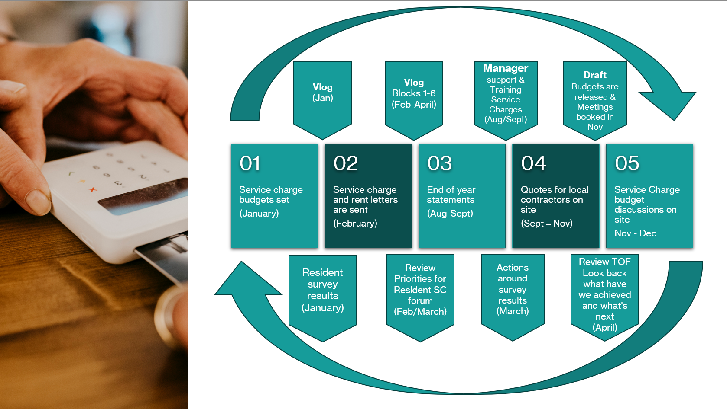
Service Charge manager survey Results
