Acuity Research and Practice logo.
 
This includes the tagline, 'Intelligence. Insight. Improvement' below the word 'Acuity', and three i's and a full stop in the shape of a triangle to the right. 

**Tenant Satisfaction Measures – Summary of Approach 2024/25**

**Housing 21 - LCRA**

**Table of Contents**

Introduction 3

Summary of Achieved Sample & Sample Method 3

Timing of Survey 4

Collection Method(s) 4

Sample Method 4

Representativeness 5

Questionnaire 9

## **Introduction**

The Tenant Satisfaction Measures (TSM) Standard mandates that all registered providers develop and report TSMs in accordance with the guidelines set by the regulator. As part of this requirement, it is necessary for Housing 21 to inform its customers about its approach to conducting the TSM Perception survey and collecting data.

This document details Housing 21’s methodology and outlines the criteria specified in the Regulator of Social Housing’s publication, Tenant Satisfaction Measures Return.

The Tenant Satisfaction Measures (TSM) Standard requires all registered providers to conduct tenant perception surveys and report performance annually as specified by the RSH. TSMs are intended to make landlords’ performance more visible to tenants so that tenants can hold their landlord to account. TSMs consist of 22 measures: 10 providing management information from data held by the landlord and 12 satisfaction measures gathered from tenant surveys. In addition to overall satisfaction with landlord services, the measures cover five key themes:

* Keeping properties in good repair
* Maintaining building safety
* Respectful and helpful engagement
* Responsible neighbourhood management
* Effective handling of complaints

Providers must publish a summary of the survey approach used to generate published tenant perception measures. This must be made clearly available alongside each set of tenant perception measures published by the provider.

## **Summary of Achieved Sample & Sample Method**

Housing 21 works with Acuity Research & Practice Ltd, an accredited organisation that is dedicated to providing research services in the social housing sector. We use survey information to understand how our tenants feel about their homes and services and how we can improve. Acuity was commissioned for collecting, generating and validating reported perception measures.

In 2024/25, Housing 21 completed TSM surveys with a census. Housing 21 must ensure that they survey enough residents to meet a statistical accuracy (margin of error at 95% confidence interval) of +/- 3%.

During 2024/25, Housing 21 completed 11,529 TSM surveys. Housing 21 have 19,029 LCRA properties which means that a statistical accuracy level of +/- 0.6% was achieved, which is a greater level of accuracy than required.

No tenant was removed from the sample frame.

Incentives:  
All surveys will be entered into a prize draw with a chance to win one of 10 x £50 Vouchers.

## **Timing of Survey**

Housing 21 completed a total of 11,529 surveys between 20/05/2024 and 14/02/2025.



## **Collection Method(s)**



The TSM Surveys were completed via Postal, Telephone and Online Surveys. The rationale for using a mixed methodology approach is:

* **Accessibility and Inclusivity**: Ensuring accessibility for all tenants, which aligns with our goal of reaching a broad and representative sample.
* **Engagement and Data Quality**: Indirect interaction by paper and online, and direct interaction over the phone tends to enhance engagement, allowing participants to answer clarifying questions and leading to more accurate and detailed responses. This is particularly valuable for nuanced satisfaction metrics.
* **Response Rates**: Using a mixed method approach maximises the robustness of our data and ensuring the results truly reflect the tenant base. Continuing to include a telephone aspect also allows Housing 21 to be reactive to flags and alerts, which improves customer recovery.
* **Reliability and Consistency**: Maintaining consistency with previous years' methodologies allows for more reliable trend analysis. It also enables richer information to be gathered.
* **Independence**: Using Acuity, an independent market research agency, means that participants are free from influence from the rest of the organisation.

## **Sample Method**

Telephone surveys were provided at the request of residents who required an alternative survey format. All residents receiving paper questionnaires had the opportunity complete the survey online via a QR code or URL link by following the instructions provided on the covering letter. The survey is carefully scripted to ensure a professional and consistent process.

Survey responses are anonymised and shared with Housing 21, so that feedback can be analysed to understand how we can improve.

A breakdown of responses by method can be seen overleaf.

**Sample breakdown**

|  |  |
| --- | --- |
| **Method** | **Achieved sample** |
| Telephone | 121 |
| Internet | 431 |
| Face to face |  |
| Postal | 10977 |
| SMS |  |
| All other methods |  |
| Total sample size achieved | 11529 |

**Representativeness**

Representative checks were carried out to ensure that the survey was representative of the tenant population as a whole. The characteristics by which representativeness was determined were:

|  |  |  |
| --- | --- | --- |
| **Tenure Type** | **Population** | **Sample** |
| Assured | 98% | 95% |
| Care Only | 0% | 1% |
| Secure | 0% | 0% |
| Tenant Rented | 0% | 1% |
| Unknown | 2% | 4% |

|  |  |  |
| --- | --- | --- |
| **Length of Tenancy** | **Population** | **Sample** |
| A. < 1 year | 22% | 22% |
| B. 1 - 3 years | 34% | 36% |
| C. 4 - 5 years | 10% | 10% |
| D. 6 - 10 years | 18% | 17% |
| E. 11 - 20 years | 11% | 11% |
| F. Over 20 years | 2% | 2% |
| Unknown | 0% | 3% |

|  |  |  |
| --- | --- | --- |
| **Age Group** | **Population** | **Sample** |
| 0 - 24 | 0% | 0% |
| 25 - 34 | 0% | 0% |
| 35 - 44 | 0% | 0% |
| 45 - 54 | 1% | 1% |
| 55 - 59 | 5% | 4% |
| 60 - 64 | 10% | 8% |
| 65 - 74 | 30% | 28% |
| 75 - 84 | 33% | 34% |
| 85 + | 21% | 22% |
| Unknown | 0% | 3% |

|  |  |  |
| --- | --- | --- |
| **Business Stream** | **Population** | **Sample** |
| Extra Care | 38% | 43% |
| PPP-PFI | 3% | 3% |
| Retirement Living | 60% | 52% |
| Unknown | 0% | 2% |

|  |  |  |
| --- | --- | --- |
| **Region** | **Population** | **Sample** |
| Acquisitions | 7% | 6% |
| East Anglia | 8% | 7% |
| EC Kent | 1% | 1% |
| Extra Care Central | 9% | 12% |
| Extra Care London | 5% | 6% |
| Extra Care North | 9% | 11% |
| Extra Care South | 7% | 8% |
| Kent PFI | 2% | 2% |
| London Kent | 8% | 7% |
| Mid East | 7% | 6% |
| Mid South | 8% | 7% |
| Mid West | 8% | 6% |
| North East | 5% | 5% |
| South West | 5% | 4% |
| Unknown | 0% | 0% |
| Walsall PPP Services | 1% | 1% |
| Yorks Lancs | 11% | 9% |

|  |  |  |
| --- | --- | --- |
| **Patch** | **Population** | **Sample** |
| Berks and Hampshire North | 0% | 1% |
| Cambridgeshire and Bedfordshire | 2% | 2% |
| Cheshire and Lancashire | 2% | 1% |
| Derbyshire and Nottinghamshire | 3% | 2% |
| Devon Cornwall and South West Somerset | 2% | 2% |
| Dorset | 1% | 1% |
| Durham Cleveland and Cumbria | 2% | 2% |
| East and West Sussex | 2% | 2% |
| EC Central 1 | 2% | 2% |
| EC Central 12 | 2% | 0% |
| EC Central 13 | 2% | 0% |
| EC Central 16 | 0% | 0% |
| EC Central 17 | 0% | 0% |
| EC Central 18 | 0% | 0% |
| EC Central 19 | 0% | 0% |
| EC Central 2 | 2% | 3% |
| EC Central 20 | 0% | 0% |
| EC Central 21 | 0% | 0% |
| EC Central 22 | 0% | 0% |
| EC Central 24 | 0% | 0% |
| EC Central 25 | 0% | 0% |
| EC Central 26 | 0% | 0% |
| EC Central 28 | 0% | 0% |
| EC Central 29 | 0% | 0% |
| EC Central 3 | 2% | 2% |
| EC Central 30 | 0% | 0% |
| EC Central 32 | 0% | 0% |
| EC Central 33 | 0% | 0% |
| EC Central 34 | 0% | 0% |
| EC Central 35 | 0% | 0% |
| EC Central 36 | 0% | 0% |
| EC Central 38 | 0% | 0% |
| EC Central 39 | 0% | 0% |
| EC Central 4 | 2% | 3% |
| EC Central 40 | 0% | 0% |
| EC Central 5 | 1% | 1% |
| EC Central 6 | 0% | 0% |
| EC Central 7 | 0% | 0% |
| EC North 1 | 2% | 2% |
| EC North 2 | 2% | 3% |
| EC North 3 | 1% | 2% |
| EC North 4 | 1% | 2% |
| EC North 5 | 2% | 2% |
| EC South 1 | 1% | 2% |
| EC South 2 | 2% | 2% |
| EC South 3 | 2% | 2% |
| EC South 4 | 2% | 2% |
| Essex and Hertfordshire | 2% | 2% |
| Glos Oxford and South Bucks | 2% | 2% |
| Greater Manchester | 3% | 2% |
| Hampshire South and IOW | 3% | 2% |
| Kent 1 | 1% | 1% |
| Kent 3 | 0% | 0% |
| Kent North | 2% | 2% |
| Kent PFI | 2% | 2% |
| Kent South Coast | 2% | 2% |
| Lancashire | 2% | 2% |
| Lancashire and West Yorkshire | 3% | 2% |
| Lincolnshire and Leicestershire | 2% | 2% |
| London 1 | 2% | 2% |
| London 2 | 1% | 1% |
| London 3 | 1% | 2% |
| London 4 | 1% | 1% |
| Merseyside | 1% | 1% |
| Norfolk | 2% | 2% |
| North and East London | 2% | 2% |
| North and East Yorkshire and NE Lincs | 1% | 1% |
| North East Somerset Wilts and Avon | 1% | 1% |
| Patch 1 | 2% | 2% |
| Patch 2 | 2% | 2% |
| Patch 3 | 2% | 2% |
| South London and Surrey | 2% | 2% |
| South Yorkshire and South Manchester | 1% | 1% |
| Staffordshire | 2% | 1% |
| Suffolk | 2% | 1% |
| Tyne and Wear and Northumberland | 2% | 2% |
| Unknown | 0% | 0% |
| Walsall PPP Services | 0% | 1% |
| Warwickshire and Northamptonshire | 2% | 2% |
| West Mids Hereford and Worcs | 0% | 2% |
| West Yorkshire | 3% | 2% |

See “Appendix A” for Scheme Representatives check.

## **Questionnaire & Introductory Text**



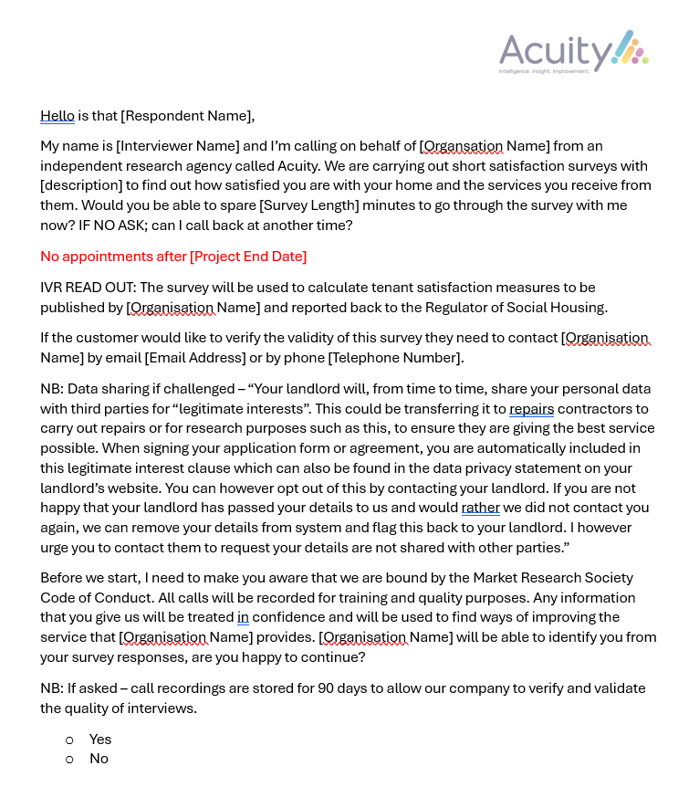

**Question Set**

acuity@arap.co.uk

01273 287114

**Report by Acuity Research & Practice**

01273 287114

acuity@arap.co.uk