
Complaints and Compliments Policy and Procedure
If you need any information in a different format, for example large print, Braille, audio file or another language, please email Communications@housing21.org.uk

Version number | 9.2
Issue date | May 2024
Review date | May 2027
Board approval required? | Yes
If yes, date approved by Board | June 2025
Author’s name and job title | Vanessa Pritchard-Wilkes, Head of Research and Influence
Policy owner and job title | Kris Peach, Chief Operations Officer
Policy Steering Group approval date | May 2024

Summary
We aim to provide high quality services and welcome all feedback, both positive and negative. We will ensure that compliments are passed on to employees and their line manager to both celebrate and identify areas of good practice.
Should we fail to meet the standards we set, or expectations around our services, this policy sets out how we will seek to respond and remedy issues raised to us. We recognise that early and local resolution of complaints is key to effective complaint handling. Complaints are an opportunity to learn and to improve our service provision across Housing 21, whilst developing good practice for employees through the provision of ongoing learning and development. Residents who make a complaint must not be treated any differently compared to those who haven’t and must receive the same respect and level of service as every other resident.
We apply a clear, simple and accessible two-stage policy around complaints to ensure they are resolved promptly and fairly for residents in a way that also meets the requirements of the Housing Ombudsman’s Complaint Handling Code.
Our definition of a complaint is as set out by the Housing Ombudsman Complaints Handling Code (2024):
“An expression of dissatisfaction, however made, about the standard of service, actions or lack of action by the organisation, its own employee, or those acting on its behalf, affecting an individual resident or group of residents”.
Our Resident Complaint Panel, who provide scrutiny across all areas of complaint handling, feel a complaint is something that has affected a resident’s peaceful enjoyment of living on their scheme, which Housing 21 has not dealt with very well, and is in line with the Housing Ombudsman definition.
This policy and separate employee management guidance set out clear direction on:
- How to deal with compliments, service requests and complaints received from and on behalf of our residents, tenants, leaseholders and clients or someone acting on their behalf.
- How complaints should be recorded, managed and concluded.
- How to manage any persistent complainants fairly and consistently.
Our event reporting system (ERICA) is used to record and monitor various processes. This includes recording compliments and complaints; and providing a structured approach to implement improvements to services as a result of customer feedback.
This policy applies to all current and former Housing 21 residents, tenants, and leaseholders, or a third party or representative, acting on their behalf (with consent) where the issue has arisen within the last 12 months; and all employees responsible for handling complaints and compliments.
Housing 21 employees should also refer to the management guidance for detailed guidance and procedures.

Contents
Background and Definitions 4
1. Compliments 4
2. What is a complaint? 4
3. What is not a complaint? 4
4. Who can make a complaint? 5
5. How will complaints be received? 5
6. Equality, Diversity and Inclusion and Reasonable Adjustments 5
Complaints Procedure 6
7. What is the formal complaints procedure? 6
8. Other advice 7
9. Are all complaints dealt with under this complaints procedure? 8
10. Resident engagement 9
11. Oversight and outcomes 9
12. Resident Satisfaction 10
13. How we work with unreasonably behaviour around complaints 11
14. Data Retention 11
15. Other related policies and procedures 11
16. Legislation or regulatory requirements 12
Appendix A Overview of Two-stage Complaints Process 13
Scheme Based 13
Central Services 14
Complaint Handler Response 15
Stage Two Escalation 16
Appendix B - Safeguarding and Domestic Abuse Concerns 17

Background and Definitions
- What is a compliment?
  - A compliment is an expression of gratitude for a service provided on or on behalf of Housing 21. We encourage all kinds of feedback, anyone who has a relationship with Housing 21 can compliment an employee, team or the organisation. Compliments are logged recorded in our event reporting system called ERICA, and shared via our operational performance reporting. We ensure the details are passed on to the relevant employee and their line manager, so that the recognition can be acknowledged, and areas of good practice identified.
We welcome receipt of compliments about our employees and services
2.0 What is a complaint?
2.1 Our definition of a complaint is as set out by the Housing Ombudsman Complaints Handling Code (2024):

“An expression of dissatisfaction, however made, about the standard of service, actions or lack of action by the organisation, its own employee, or those acting on its behalf, affecting an individual resident or group of residents”.
The complainant does not have to use the word ‘complaint’ for it to be treated as such.

Complainants will be treated fairly and not treated any differently as a result of making a complaint.
The term ‘complaint handler’ used in this policy refers to the Housing 21 employee who is handling the complaint.

3. What is not a complaint?
3.1 A service request is defined by the Complaint Handling Code as ‘a request from a resident to the landlord requiring action to be taken to put something right’ but that ‘a complaint must be raised when the resident expresses dissatisfaction with the response to their service request’. As such, a first-time request for service from a resident will be entered into the relevant policy or procedure such as repairs, anti-social behaviour, nuisance or safeguarding and recorded on the appropriate housing management system and not recorded as a complaint. Where a resident does not wish to make a complaint, this should be recorded on ERICA.

If the resident is dissatisfied with how we propose to handle their service request, or the ongoing handling of their service request, we will offer them the opportunity to make a stage one complaint to address their concerns.

3.2 Some issues may have to be dealt with under other procedures such as repairs, anti-social behaviour or safeguarding because they are requests for service or because of other conflicts, detailed later in this policy in section nine. Only these would constitute a valid reason not to accept an issue as a complaint, which would be set out to the complainant and recorded for reporting purposes.
Please see Appendix A of the procedure for a flow chart to support this decision-making process.

4. Are all complaints dealt with under this complaints procedure?
4.1 Some complaints or escalations may be actioned under separate arrangements. These include the following:
- a first-time request for service, rather than a complaint about the services received such as repairs – refer to the repairs policy, Anti-social behaviour – refer to ASB policy and procedure; safeguarding or domestic abuse concerns - refer to Appendix A and the Safeguarding Policy and Domestic Abuse Policy.
- services for which Housing 21 are not responsible;
- matters already considered through both stages of the complaints policy;
- complaints which occurred over 12 months ago unless part of a recurring issue or whether consideration of older reports will help to resolve the issue;
- insurance claims; these are dealt with by our insurers;
- where the complainant is taking legal action against Housing 21 on the same issue (where possible this should not stop us continuing to resolve the local issue); or where Housing 21 is taking legal action against the complainant on the same issue and details of the claim have been filed at Court;
- complaints submitted anonymously (although investigation will be attempted where possible);
- complaints about our procurement process from contractors and suppliers;
- data protection breach which is dealt with under GDPR;
- where the complainant is an employee of Housing 21 (unless they occupy a Housing 21 property and the complaint related to issues around their tenancy) and the issue maybe better addressed via Human Resources policies e.g. grievance; and
- for employees who are keen for concerns to be raised so something can be done to bring about a positive change, please consult the Whistleblowing Policy.

4.2 The Head of Service will decide which arrangement should apply. If a complaint is not accepted for consideration or escalation, an explanation should be provided to the complainant setting out the reasons why the issue is not suitable for the complaint procedure and where relevant what procedure is being followed. We will also advise that the complainant has the right to take this decision to the Housing Ombudsman for review.

4.3 Where a service is not provided or managed by Housing 21 this will be clearly communicated to the complainant at the earliest opportunity. However, this not to undermine any assistance Housing 21 can offer to support or advise a complainant.

5. Who can make a complaint?
5.1 Complaints about our services may come from any source including: current and former residents; family members of residents; friends, neighbours, or advocates of residents; service users; service providers; or professionals where the issue has occurred within the last 12 months and affects an individual resident or group of residents.

5.2 A complaint that is submitted via a third party or representative must have the resident’s consent or be via a legal power of attorney and will be handled in line with the complaints policy. As such is also included in the term ‘complainant’ as applied through this policy.
5.3 Any complainant has the right to be represented or accompanied at any meeting with Housing 21
5.4 Residents who make a complaint must not be treated any differently compared to those who haven’t and must receive the same respect and level of service as every other resident.

6. How will complaints be received?
6.1 Most complaints will be received locally by a scheme manager at the relevant court or scheme and escalated to their line manager.
6.2 It is also possible that enquiries compliments, service requests and complaints are received by other employees whether by phone, letter, via social media, or by email, or directly to the dedicated complaints and feedback email address or phone line. These contacts will be acknowledged and forwarded to the most relevant employee for response. Our process for allocation of any such contacts will follow the appropriate line management structure according to the type and nature of the communication received. For example, direct to the Scheme Manager, their line manager or if an enquiry about an employee within Finance, it may have been direct to Finance.

6.3 It is a requirement of the Complaints Handling Code (CHC)that a standard objective is included in all quarterly conversations held with employees who respond to complaints.

7. Equality, Diversity and Inclusion and Reasonable Adjustments
7.1 Housing 21 aspires to embed diversity and inclusion within all our organisational activities to enable these principles to become part of our everyday processes. We take diversity seriously and will ensure that residents are treated fairly whatever their circumstances.

7.2 We consider any resident vulnerabilities, disclosed disabilities, and reasonable adjustments as part of our complaint handling and record on ERICA, our complaint recording system. Should we receive a request for an adjustment to accommodate a complainant’s needs, we will assess the request and make provision if deemed reasonable by the complaint handler. We will agree any extended complaint response deadlines with the complainant if needed. If further advice is required, the view of our Respect and Inclusion Partner will be sought.

Complaints Procedure

8. What is the complaints procedure?
8.1 Complainants who are dissatisfied with any aspect of their service or response to their service request can escalate to the two-stage procedure, at any time, through any of the routes available: in person via their Scheme Managers, through our feedback telephone line, email address or social media.

8.2 At stage one, complaints should be acknowledged within five working days by the appointed complaint handler from the date of receipt as day 0. The complaint handler can contact the complainant to agree the nature of their complaint, or ‘complaint definition’, the preferred outcome/s and timescales for response, which will then be included within a stage one acknowledgement.
Where residents raise additional complaints during the investigation, these must be incorporated into the stage one response if they are related and the stage one response has not been issued. Where the stage one response has been issued, the new issues are unrelated to the issues already being investigated or it would unreasonably delay the response, the new issues must be logged as a new complaint.

8.3 Stage one complaints will be triaged by the complaint handler with support from the complaints team which includes an assessment of any resident vulnerabilities, whether the need for an extension is likely and other considerations around the investigation, investigated and responded to within the subsequent 10 working days. The response is reviewed by their Line Manager.

8.4 The complaints officers within both business streams have access to employees at all levels to ensure the prompt resolution of complaints.
8.5 If it is not possible to respond within 10 working days, contact must be made to advise of the required extension period with the complainant, preferably with their agreement and confirmed in writing. This will generally be up to 10 working days unless there are extenuating circumstances. Should a complainant be dissatisfied with the application of an extension period, we advise that the complainant has the right to take this decision to the Housing Ombudsman for review.

8.6 Complainants who are dissatisfied with any aspect of the stage one response can then ask to escalate to stage two, within a six-month period from the date of the stage one response, however each request outside of this time must be considered on its own merits. A stage two review is conducted by the Managing Director / Director for the area of business to which the complaint relates to ensure an impartial review of the stage one investigation and response. Only the reasons set out in section nine would constitute a valid reason not to accept an escalation of the complaint, which would be set out to the complainant and recorded on ERICA.

8.7 Stage two escalations should be forwarded to the complaints inbox, where a member of the Complaints Team will contact the complainant to agree the nature of their dissatisfaction with the stage one response, their preferred outcome/s and timescales for response. These will be included in the stage two acknowledgement which must be issued within five working days from the date of escalation/receipt. However, it should be noted that a complainant does not need to provide a reason for escalation, and the information included within any escalation should be included within the stage two acknowledgement.

8.8 Stage two complaints should be responded to within 20 working days of acknowledgement. If it is not possible to respond within 20 working days, contact will be made to advise of the required extension period with the complainant, preferably with their agreement. This will generally be up to 20 working days unless there are extenuating circumstances. Should a complainant be dissatisfied with the application of an extension period, we advise that the complainant has the right to take this decision to the Housing Ombudsman for review.

8.9 This will conclude our complaints procedure. Should a complainant remain dissatisfied with the outcome of their complaint, we advise that the complainant has the right to take this decision to the Housing Ombudsman for review.

8.10 A separate employee guidance document further details management of the process and record keeping. However, where required refer to your line manager or the Complaints Team for support and advice.
8.11 Any actions being undertaken as a result of a complaint must be tracked by the complaint handler and the resident (or advocate) must be given appropriate updates. 9. Other advice
9.1 A complainant can approach the Housing Ombudsman during any stage of a complaint for advice; although they cannot take up a case until the providers complaints process has been completed. Contact details of the Housing Ombudsman are included in correspondence throughout all the stages of a complaint, including should we not accept a complaint, or when extending a complaint Complainants may wish to seek support from other agencies such as Citizens Advice, The Leasehold Advisory Service or Shelter to aid the resolution of disputes.

Housing Ombudsman contact details are also made available on scheme posters and newsletters. A leaflet aimed at residents explains the complaints policy and procedure and how to access it. This leaflet is available on request and via our website alongside this policy, which is also available on request.

9.2 In the case of complaints relating to care services the complainant can approach the relevant local authority if appropriate and the Local Government and Social Care Ombudsman where a complainant has been through the two-stage complaints process.

9.3 Where complaints are referred to the Ombudsman Service, we will co-operate fully with any investigation and comply with the resulting decision.

9.4 In the case of complaints relating to certain types of disputes such as service charges or rent increases, an application can be made to the First Tier Tribunal (Property Chamber) - (leaseholders and tenants). For a full list of their areas of jurisdiction and contact details for regional offices, please refer to: https://www.gov.uk/courts-tribunals/first-tier-tribunal-property-chamber.

9.5 Further information and advice on any of these options can be obtained from the Complaints Team

10. Resident engagement
10.1 As part of our ongoing work with residents around complaints, we support a Residents Complaints Panel to provide scrutiny of our policy and procedure, our performance and to review a sample of our complaints responses for quality, fairness and lessons learnt.

11. Oversight and outcomes
11.1 We aim to provide high quality services and to welcome, understand and resolve individual complaints within the prescribed timescales or sooner. We will apply a consistent approach that allows for monitoring. We will learn from complaints to improve our service provision across Housing 21, whilst developing good practice for employees. Where relevant, line managers will include an objective around complaints as part of their quarterly conversation.

11.2 Performance reporting against the key performance indicators is provided to Board, Executive Committees and line management structures to include;
- regular updates on the volume, categories and outcomes of complaints, alongside complaint handling performance
- regular reviews of issues and trends arising from complaint handling
- regular reports around wider lessons learnt and service improvements where applicable
- regular updates on the outcomes of the Ombudsman’s investigations and progress made in complying with orders related to severe maladministration findings and
- an annual complaints performance and service improvement report.

11.3 Housing 21’s has an appointed Member Responsible for Complaints (the MRC) who sits on our Board. The MRC has lead responsibility for complaints to support a positive complaint handling culture and are responsible for ensuring the governing body receives regular information on complaints that provides insight on our complaint handling performance.

11.4 The Managing Director for Retirement Living is our appointed Executive Member for Complaints as the lead person accountable for complaint handling. They are responsible for assessing themes or trends to identify potential systemic issues, serious risks, or policies and procedures that require revision and the provision of information to the MRC’s.

11.5 Performance updates will also be shared with the Resident Complaint Panel, and all residents via scheme newsletters, the website and the annual Complaints Performance and Service Improvement report alongside the Complaint Handling Code self-assessment and Board response to the annual report.

12. Resident Satisfaction
12.1 We measure resident satisfaction with our complaints process on a regular basis, with a monthly complaints survey for those who have made a complaint to us. This survey gives residents an opportunity to express their satisfaction with particular aspects of the complaints process, such as timeliness and it being a neutral process. It also provides an opportunity for residents to give their open comments on areas for improvement. Reporting takes place on a quarterly basis, and the results are shared with members of the Executive team, Resident Complaints Panel and to line management structures through their performance reporting.

12.2 Complaint satisfaction at a national level is measured annually through our Residents’ Survey, which includes the Tenant Satisfaction Measures (TSMs) set out by the Regulator of Social Housing. One TSM covers complaint handling in particular, and the satisfaction score from this measure is used as a key performance indicator. A summary report of our annual TSM results is shared widely across the organisation, as well as the individual scheme reports.
- How we work with unreasonably behaviour around complaints
13.1 Employees will inevitably come into contact with a small number of complainants who complain; but in doing so take up an unwarranted amount of time and/or impede the investigation of their or another person’s complaint.
13.2 We have adopted the Local Government and Social Care Ombudsman’s definition:

“For us, unreasonable and unreasonably persistent complainants are those complainants who, because of the nature or frequency of their contacts with an organisation, hinder the organisation’s consideration of their, or other people’s, complaints.”

13.3 When dealing with such complainants we will ensure that we do so consistently, fairly and reasonably. We do not view behaviour as unreasonable just because someone is assertive or determined.

13.4 Employees should reference our Managing Unreasonable Behaviour Policy. Any restrictions being considered on a resident’s contact due to unacceptable behaviour should be appropriate to their needs and should demonstrate regard for the provisions of the Equality Act 2010.

14. Data Retention
14.1 The data retention period relating to complaints and compliments has been set as the life of the tenancy plus 12 months. This supports the requirement for previous relevant complaint investigations to be included in current complaints where required. Should the complaint link to an ongoing legal case then we will retain the data in line with the Limitation Act.

15. Other related policies and procedures
- Complaints and Compliments Management Guidance
- Anti-Social Behaviour Policy and Procedure
- Safeguarding Adults Policy and Procedure
- Managing Unreasonable Behaviour Policy
- Compensation and Remedies Policy and Procedure
- Social Media Policy
- GDPR Policy and procedures
- Whistleblowing Policy
- Alternative Formats Policy and Procedure
- Reasonable Adjustments/Alternative Formats Policy and Procedure

16. Legislation or regulatory requirements
- Housing Act 1985, 1988, 1996 and 2004
- Localism Act 2011
- Landlord and Tenant Act 1985
- Equality Act 2010
- Transparency, Influence and Accountability Standard
- Data Protection Act 2018
- The Regulator of Social Housing
- General Data Protection Regulation
- The Social Housing (Regulation) Act 2023
- Housing Ombudsman Service Complaint Handling Code 2024

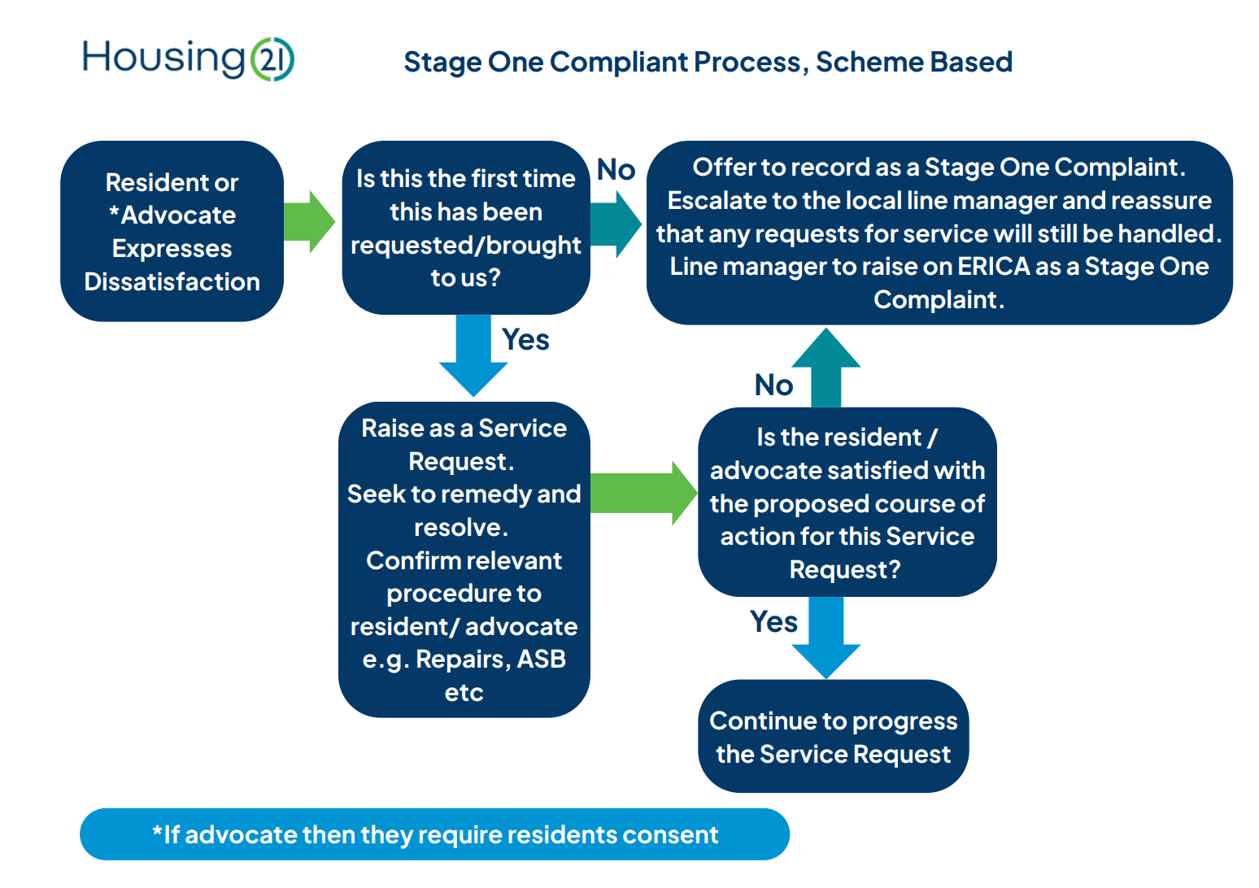
Appendix A Overview of Two-stage Complaints Process

Scheme based

- 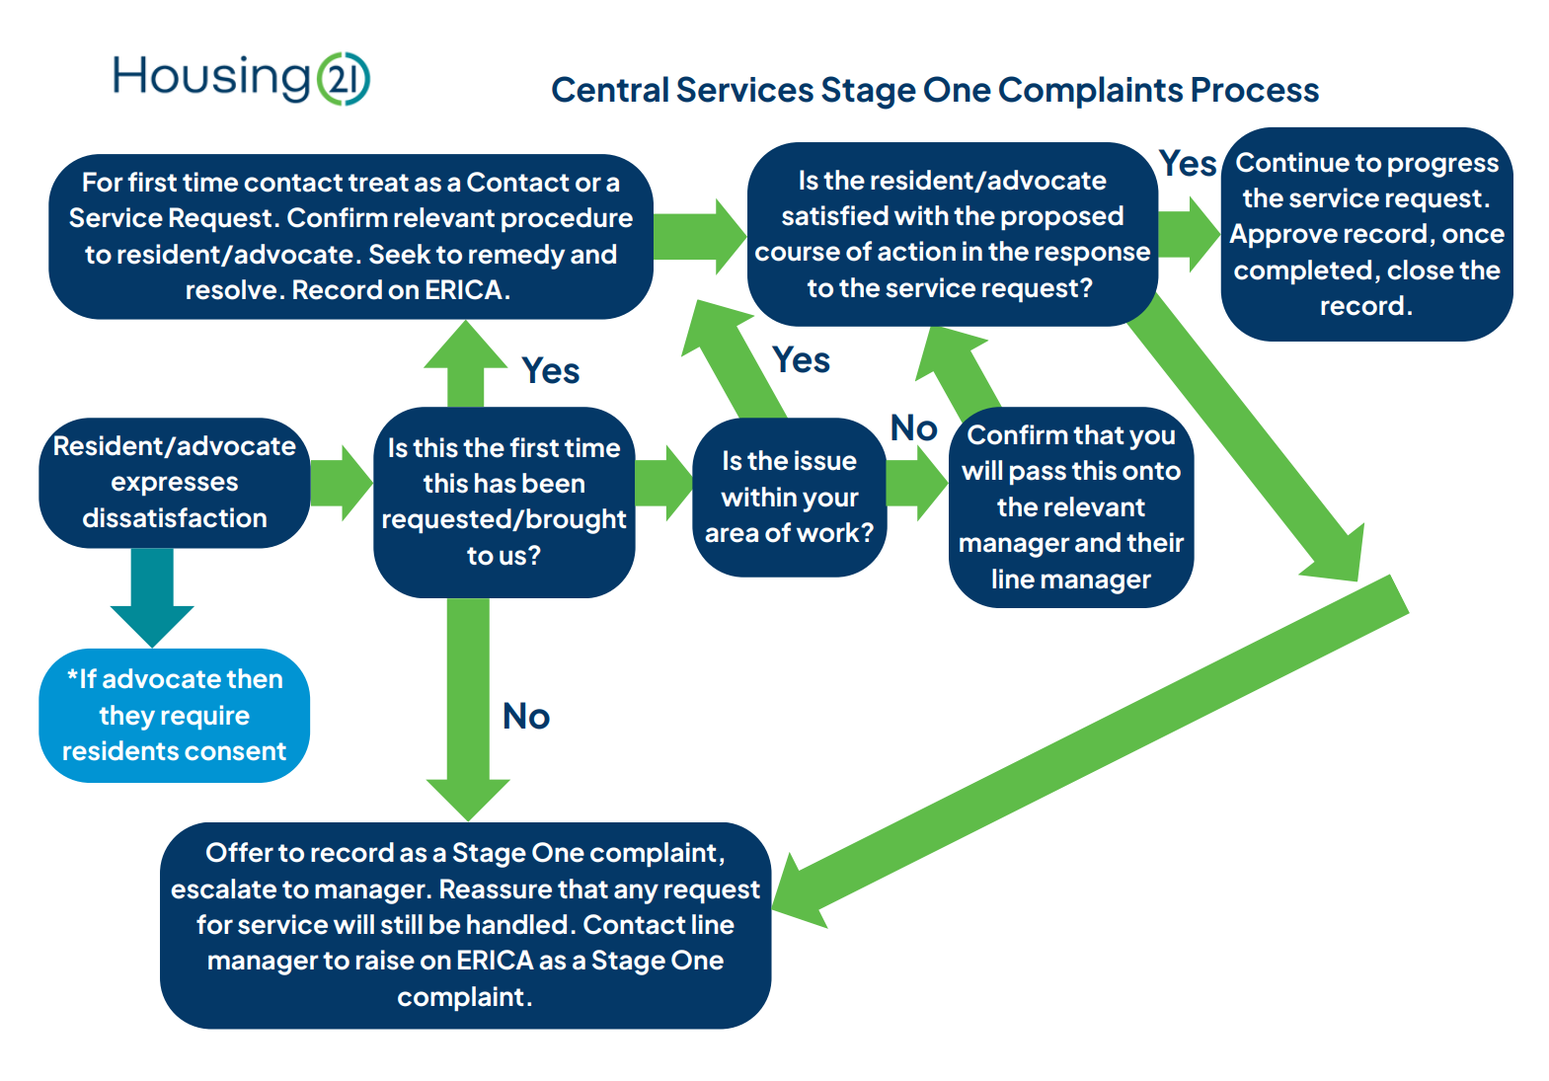

Central Services
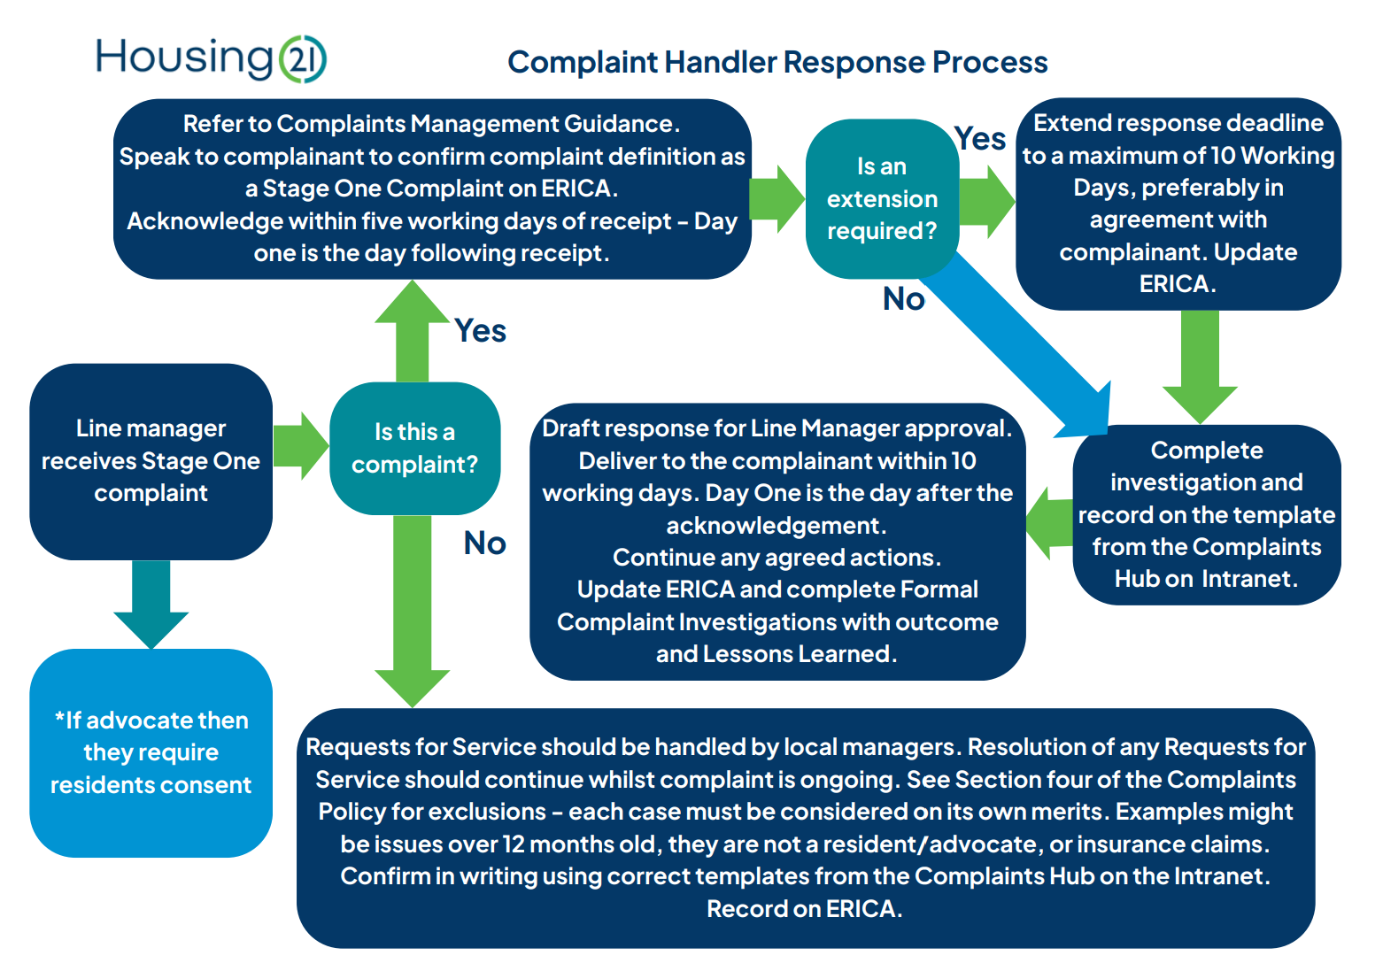

Complaint Handler Response

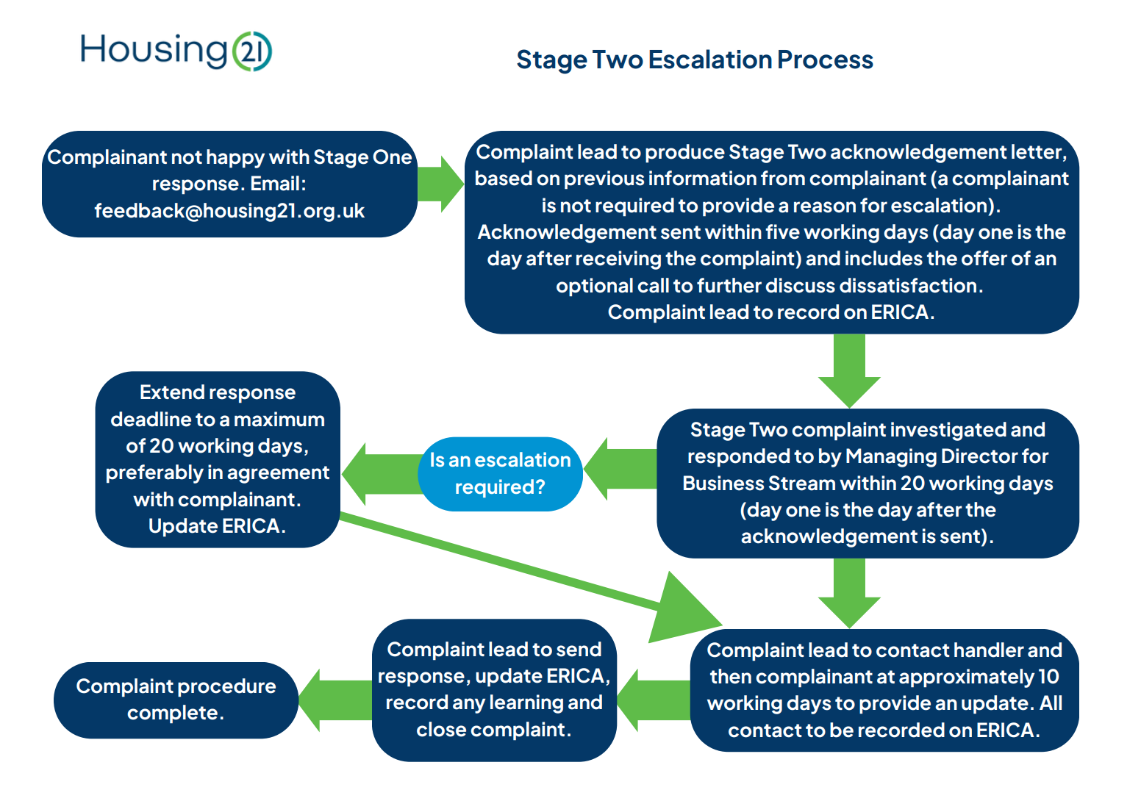

Stage Two Escalation

Appendix B - Safeguarding and Domestic Abuse Concerns
When considering the nature of a complaint employees need to ensure the complaint or concern is not a safeguarding or domestic abuse concern. Should this be the case, employees must follow the Housing 21 Safeguarding and/or Domestic Abuse Resident policy and procedure.
As a provider of housing and care services for older people we have a duty to act appropriately to any allegations, reports or suspicions of neglect and or abuse. The Safeguarding policy applies to all Housing 21 customers (which for the avoidance of doubt includes individuals living in the community in a home owned and/or managed by Housing 21 irrespective of whether they are named on a Housing 21 tenancy agreement or lease).
In line with the Care Act (2014) we aim to:
- stop abuse or neglect wherever possible;
- prevent harm and reduce the risk of abuse or neglect to adults with care and support needs;
- safeguard adults in a way that supports them in making choices and having control about how they want to live;
- promote an approach that concentrates on improving life for the adults concerned;
- raise public awareness so that communities as a whole, alongside professionals, play their part in preventing, identifying and responding to abuse and neglect;
- provide information and support in accessible ways to help people understand the different types of abuse, how to stay safe and what to do to raise a concern about the safety or well-being of an adult; and address what has caused the abuse or neglect; and
- keep the resident informed of any referrals that are in best interest or meet the safeguarding overriding consent criteria.

The domestic abuse policy covers all residents and Housing 21 define domestic abuse not only with the care act 2014 for those with care and support needs but also the national standard definition with the Domestic Abuse Act 2021. As a provider in relation to domestic abuse we aim to:
- Positively support residents who are living with and surviving domestic abuse;
- Supporting survivors to remain in their own home if they wish or a management move to safe accommodation away from the perpetrator;
- Providing timely and effective guidance and partnership working to support survivors of domestic abuse;
- Enhancing safety and security of survivors of domestic abuse;
- Working in partnership with organisations to support perpetrators of domestic abuse to change their behaviour;
- Raise public awareness so that communities as a whole are able to understand and recognise domestic abuse; and
- Work with residents in a person-centered way.

